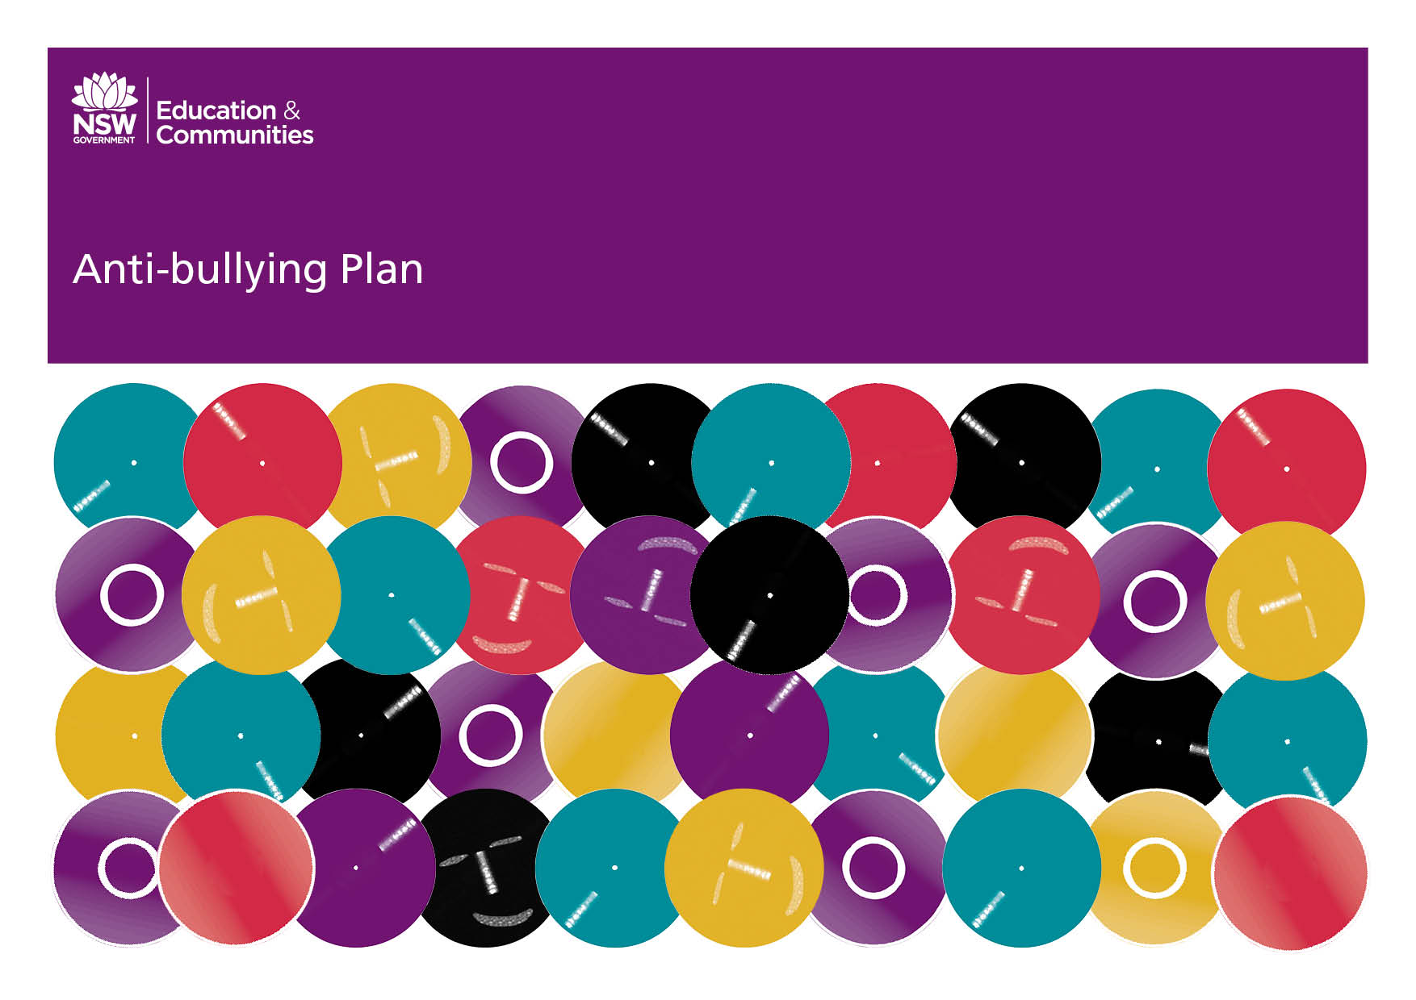
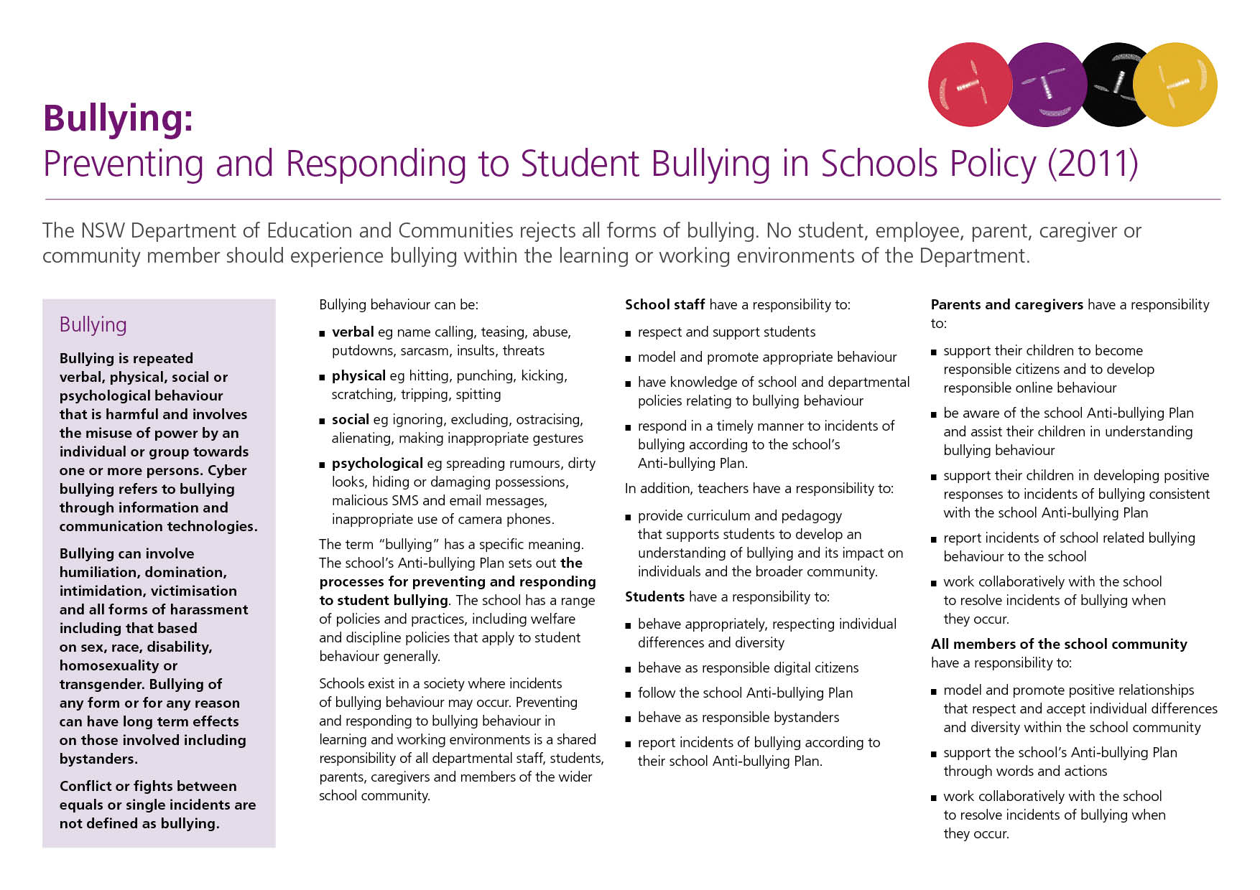
Hazelbrook Public School

Hazelbrook School Anti-Bullying Plan 2020
This plan outlines the processes for preventing and responding to student bullying in our school and reflects the Bullying: Preventing and Responding to Student Bullying in Schools Policy of the New South Wales Department of Education and Communities.
The school’s team consists of teaching and non-teaching staff, student and parent representation. Initial evaluation and draft changes of current policy student wellbeing data will be undertaken by executive staff. This will be shared with staff and a representative group of parents and students for evaluation and review. Final modifications to the policy will be made as per evaluation and review by executive staff. The final policy will be distributed to all staff, students and families as well as published on the school website. The policy will be implemented by all staff and further evaluated and reviewed within three years.

Statement of purpose
At Hazelbrook Public School we are all respectful, responsible learners. Our Anti-Bullying Policy is an integral part of the school’s Student Wellbeing Policy.
Students at Hazelbrook Public School attend school to participate in quality education that will help them to become self-directed, lifelong learners who can create a positive future for themselves and the wider community.

The impact of bullying can be significant. Hazelbrook Public School recognises an obligation, derived from the rights of students, to do what it can to prevent bullying and assist students when their wellbeing is compromised.

Schools, teachers, parents, and caregivers have a shared responsibility to create a safe and happy environment, free from all forms of bullying. Parents, care givers and families have an important role to play in helping our school deal with bullying by discouraging their children from using bullying behaviour at home or elsewhere.

Hazelbrook Public School is inclusive of all students - gender, ethnicity, culture and ability. Students enrolled with a disability are entitled to a safe learning environment which will be supported through the anti-bullying plan and student welfare policies.

Protection

At Hazelbrook Public School we support all students, staff and visiting community members through:
- not tolerating bullying behaviour
- developing a shared understanding of bullying behavior that captures all forms of bullying including online bullying
- encouraging students to employ strategies taught during bullying awareness programs including PBL
- creating positive classroom environments
- providing the opportunity for disclosing acts of bullying- one on one discussion, through the classroom PBL lessons and circle time
- consistently rewarding positive behaviour and effort
- Classroom-based Personal Development Programs / Social Skills Programs/PBL
- Child Protection Program
- Drug Education Program
- Life Education Program
- K-6 Buddy Links
- Class Discussions
- Opportunities for leadership and responsibility at all levels
- An active and supportive Learning Support Team, PBL Team and P&C.

Bullying is repeated verbal, physical, social or psychological behavior that is harmful and involves the misuse of power by an individual or a group towards one or more persons.
Online bullying refers to bullying through information and communication technologies.
Conflicts or fights between equals or single incidents are not defined as bullying by the NSW Department of Education.
Bullying behaviours can include:
- Humiliation, domination, intimidation, victimization and all forms of harassment including that based on sex, race, disability, homosexuality and transgender
- interfering with another’s property by stealing, hiding, damaging or destroying it
- using offensive names, teasing or spreading rumours about others or their families
- writing offensive notes or graffiti about others
- making degrading comments about another’s culture, religious or social background
- hurtfully excluding others from a group
- making suggestive comments or other forms of sexual abuse
- ridiculing another’s appearance
- forcing others to act against their will

At Hazelbrook Public School, we are committed to the development of an environment where bullying is not tolerated. Our PBL program encourages students to ask for help. It shows students how they can ask for help without fear of retribution. Staff will always follow up and look into reported incidents to ensure that students feel their concerns have been heard.

Prevention
As a Positive Behaviour for Learning [PBL] school we explicitly teach social behaviours and skills as part of learning programs. These include:
- What is respect? and understanding what respect looks like in various school environments
- What is responsibility? and understanding what is each person’s role in making a respectful school community
To support this basic philosophy our school implements additional learning programs in peer relations through:
- Bully No More program
- Life Education program
- Jo Solo program

This requires staff to:
- implement the spirit of the school’s Student Wellbeing Policy and the school’s Positive Behaviour for Learning [PBL] processes
- be positive role models at all times
- maximise a safe learning and playground environment with active supervision when on duty and by being at assemblies and classrooms promptly
- report suspected incidents to the appropriate staff member who will follow the designated procedures as per Playground and Classroom Behaviour Referral Flowchart
- provide students with the necessary strategies for dealing with bullying through a planned series of classroom lessons in the Anti-Bullying Program as per PBL
- implement planned social skills programs for the relevant stage(s) through the implementation of Physical Education/Health/Personal Development syllabus
- develop individual behaviour modification programs and risk assessments with the learning and support team
- be observant of signs of distress or suspected incidents of bullying
- take steps to help the recipient of bullying and remove sources of distress without placing the recipient at further risk
- work co-operatively with families and the whole school community

This requires students to:
- understand the spirit and content of the school’s Student Wellbeing Policy and the school’s Positive Behaviour for Learning [PBL] processes
- participate in the strategies for dealing with bullying taught through the lessons in the Anti-Bullying Program
- participate in the planned social skills programs for the relevant stage(s)
- implement the strategies learnt through behavior modification programs
- take responsibility for their own actions
- refuse to be involved in any bullying situation
- recognise that keeping silent about a bullying situation provides support and protection for the student who displayed the bullying behaviour
- report the incident or suspected incident to a teacher

This requires families to:
- understand and support the spirit of the school’s Student Wellbeing Policy and the school’s Positive Behaviour for Learning [PBL] processes
- teach children respect for others and appreciation of differences
- observe children for signs of distress or changes in behaviour
- not encourage children to retaliate
- report incidents to the school promptly
- work co-operatively with the school to reach a solution

Early Intervention
The introduction of a school data base for student wellbeing issues provides information on the students involved, nature, frequency and location of bullying incidents. This information allows staff to develop individual plans for students [both victims and bullies] to assist in behaviour modification.
Students at risk of developing long term difficulties with social relationships will be involved in programs such as:
- peer mentoring
- buddy
- small group social skills
- counselling
- Mindfulness
Risk Management Plans are developed for students, ensuring their safety and minimizing opportunities for them to be placed in difficult situations.
Families of students arriving new to the school have a responsibility to provide accurate and up to date information regarding incidents that have involved bullying. This information will be utilized by the school to develop and implement support.

Response
Hazelbrook Public School is a PBL school and as a result is engaged in the explicit and systematic teaching of appropriate behaviours within the framework of responsible and respectful learners. Anti-bullying lessons are part of this program and are taught to, and reinforced with, students throughout the year on a regular basis. A key component of these anti-bullying lessons is teaching students how to behave as responsible bystanders. The Tell them from me survey, undertaken annually, also provides information
Families are encouraged to discuss their children’s bullying concerns with their child’s classroom teacher. Regular and timely updates will be provided to families, within the bounds of privacy legislation, about the management of bullying incidents that have been reported to the school. These updates may be provided by letter, phone, email or through face to face conversations all dependent on a variety of factors unique to the situation. In the event the bullying incident continues to be repeated after classroom teacher intervention, the stage supervisor and learning and support team will become involved. This process is communicated to the school community via the newsletter and by accessing the anti-bullying policy on the school website. The DoE has policies and procedures to ensure that procedural fairness will occur. https://cms.det.nsw.edu.au/policy-library/associated-documents/School-complaint-procedure_AC.pdf
The school will utilise the PBL classroom problem solving process to design appropriate interventions that match bullying incidents. This is tier two PBL intervention aimed at specifically reducing target behaviours and replacing them with positive behaviours.
Students who have been affected by bullying situations will be involved in specific PBL lessons to develop the necessary skills and language to overcome adversity and build resilience. They also have access to the school counsellor through the learning and support team, who in conjunction with families, will be involved in assessing the nature of assistance required.
In the event a student is injured or an illegal substance or weapon is brought to school the principal will report this incident to the Incident and Support Hotline and follow the advice provided.
As mandatory reporters when information is disclosed staff will follow the decision making tree and make reports to the appropriate service.
Regular analysis of PBL data will be used to identify patterns of bullying behaviour and allow for strategies to be implemented as developed in collaboration with the learning an support team. These strategies will occur under the PBL umbrella, with the aim to replace negative behaviours with positive behaviours.
The school, through the Department of Education and Communities, has procedures in place to deal with incidents which involve other agencies eg police, DOCs, Child Well Being unit. Copies of these procedures can be found on the DEC’s website.
The school’s Anti Bullying Plan will be monitored and reviewed for effectiveness and modified [where necessary] annually through a process of surveys, discussion, student wellbeing data collection and responses from students, staff and parents. The results of these reviews will be published in the school newsletter, the Annual School Report, the school website, with a full evaluation completed every three years.

Additional Information
Police Youth Liaison Officer at Springwood Police Station – 47510299
www.kidshelpline.com.au 1800 55 1800 (for parents and children)

Principal’s comment
Hazelbrook Public School is committed to developing and retaining a respectful, responsible learning environment for all students.

School contact information
Hazelbrook Public School
Great Western Hwy, Hazelbrook 2779
Ph: 4758 6120
Fax: 4758 8888
Email: hazelbrook-p.school@det.nsw.edu
Web: www.hazelbrook-p.school@det.nsw.edu.au

