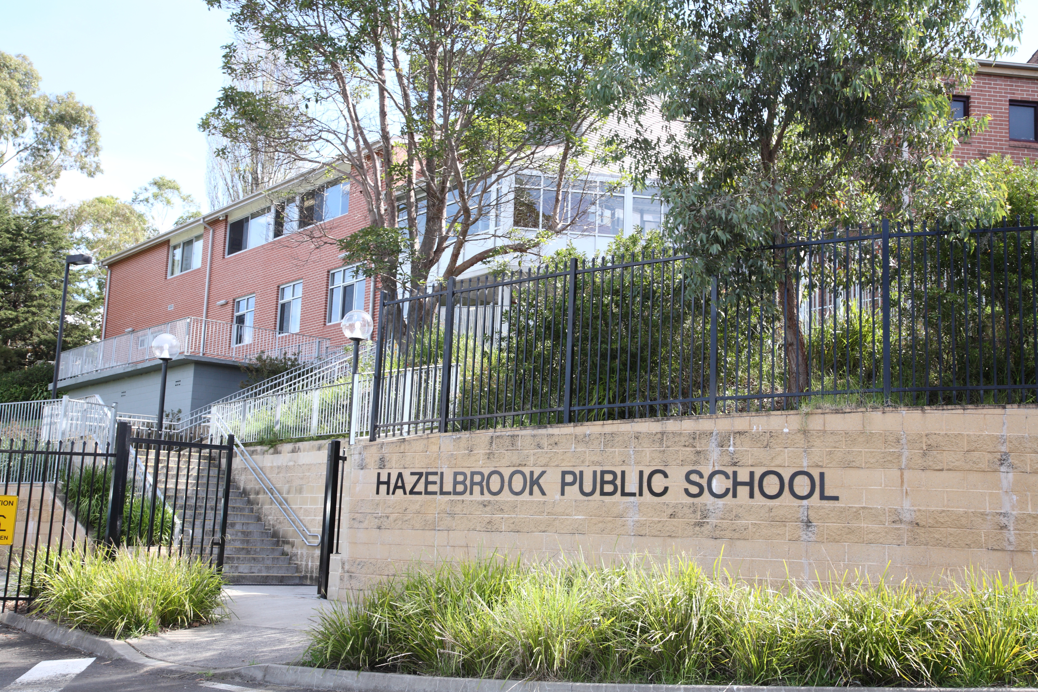
Address: Great Western Highway HAZELBROOK
NSW 2779

Phone 0247 58 6120
Fax 0247 58 8888

Email: hazelbrook-p.school@det.nsw.edu.au

Principal: Melinda Williams

Respectful, Responsible Learners ...

9.11.16
Dear Parents,
We are writing to inform you about planned changes to the Hazelbrook Public School ‘MAC’ program. The MAC program started in 2007 with 2 multi-aged classes, a K-2 and a 3-6 class. It has taken different multi-aged formats, including a 1-2 class and 3-5 class when Hazelbrook had a grade based structure. In the last 6 years we have had a stage based ‘MAC’ program consistent with our school wide stage based structure.
Recently, as part of planning for 2017, we have reviewed our ‘MAC’ structure. Part of the review involved revisiting the DoE Gifted and Talented Policy and the support document. We also examined the research of Professor Miraca Gross. Professor Miraca Gross is Emeritus Professor of Gifted Education in UNSW's School of Education as well as Director of GERRIC (Gifted Education Research, Resource and Information Centre). She is recognised nationally and internationally as a leading authority on the education of gifted and talented students.

Part of our planning discussion also involved some anecdotal reflection on whether our current model was meeting the objective of catering for our gifted and talented and high achieving students. For example, Gagné, author of the Differentiated Model of Giftedness and Talent (which has been adopted by most Australian States in their policies for gifted students), estimates that 10% of students may be gifted at some level. This is an estimation that is more inclusive than some other definitions of giftedness. Currently at Hazelbrook we have 23% of our students in a ‘MAC’ class. This is clearly an over-representation and has implications for both our ‘MAC’ and our mixed ability classes.

In 2017 we are planning to return to the multi-aged model and form one Year 2-6 multi aged extension and enrichment class / gifted and talented class. We hope to improve our ability to cater for gifted and talented and high achieving students and bring our practice into better alignment with both the Department of Education policies and current research.
The following key aspects from the Policy and Implementation for the Education of Gifted and Talented Students (revised 2004) outline our responsibilities to address the needs and cater for gifted and talented students.
- The New South Wales Government aims to identify gifted and talented students and to maximise their learning outcomes in all public schools.
- Gifted students are those whose potential is distinctly above average in one or more of the following domains of human ability: intellectual, creative, social and physical.
- Talented students are those whose skills are distinctly above average in one or more areas of human performance (Gagné’s (2003) Differentiated Model of Giftedness and Talent (DMGT).
- School communities have a responsibility to identify their gifted and talented students.
- School communities have a responsibility to foster collaborative home–school partnerships to support gifted and talented students.
- • School communities have a responsibility to provide a range of opportunities and to monitor and evaluate programs for their gifted and talented students.
- Gifted and talented students require a differentiated curriculum to cater for their academic, social and emotional needs. Programs that incorporate acceleration, enrichment, grouping and counselling options best meet the needs of gifted and talented students.

The following key aspects from our professional reading of To Group or Not To Group: Is That the Question? by Miraca U.M. Gross, Ph.D. that have led to the decision to modify our program to one full time multi aged class are as follows:
- Studies show that gifted students prefer the company of children at their own stage of intellectual and emotional development rather than students of their own chronological age.
- Studies of the “performance of gifted students in ability grouped classes where the curriculum is accelerated as well as enriched, have shown that these students gain in grade-level competencies at almost twice the rate of equally gifted students retained in the regular classroom (Kulik, 1992).” In addition to clear academic gains, there was also significant improvement in attitude towards subjects in which the students were grouped.
- Gifted students in fulltime ability grouped settings (special schools for gifted students and fulltime self-contained classes) performed significantly better than did equally gifted students who were ability grouped for only part of the week.

Professor Miraca Gross discusses the advantages of full time ability grouping for gifted and talented students and states:
- The level and pace of work in full time classes is able to be matched much more closely to the students' needs and ability. Teachers are better able to respond to gifted students who learn more speedily, retain information more effectively, and require much less repetition of instruction when they are grouped together.
- Gifted children in ability grouped settings are much less likely to underachieve deliberately, for peer acceptance. Students interviewed by Gross report “that they feel much less pressure to moderate their vocabularies, conceal interests that their classmates would not understand, and make deliberate errors in school work, than they were in previous years.”

Gross concludes:

“Influenced by a considerable body of research on the positive effects of ability grouping on both the academic and social development of gifted students, virtually every recognised authority on the education and psychology of the gifted has recommended that intellectually gifted students should be grouped together for a significant proportion of their class time (Hollingworth, 1942; Kulik and Kulik 1982, 1997; Tannenbaum, 1983; Feldhusen, 1985; Borland, 1989; Kulik, 1991; Rogers, 1991, 1998). Even educators who express concern about the practice of grouping slow learning students by ability (e.g. Oakes, 1986; Johnson and Johnson, 1989) report on the benefits that accrue to gifted students when they are grouped for fast-paced, accelerated work.

Links to the full policy documents and Professor Miraca Gross’ article, To Group or Not To Group: Is That the Question? can be found on the school website:
http://www.hazelbrook-p.schools.nsw.edu.au
It is located in the Student Engagement section under Gifted and Talented.

An open meeting for all parents to further discuss these improvements to our MAC program will be held on Tuesday, November 15 at 3:45pm in the 3/4S classroom (Rooms 1 and 2). This will be an opportunity for information to be discussed and for any questions parents may have, to be answered.
All parents are welcome to attend.
We look forward to continuing our partnership with our school community, as we endeavour to achieve the best outcomes for all our students.

Melinda Williams Michelle Schmidt
Principal Relieving Assistant Principal

